**Deep Learning**

Deep Learning is the most exciting and powerful branch of Machine Learning. Deep Learning models can be used for a variety of complex tasks:

* Artificial Neural Networks for Regression and Classification
* Convolutional Neural Networks for Computer Vision
* Recurrent Neural Networks for Time Series Analysis
* Self-Organizing Maps for Feature Extraction
* Deep Boltzmann Machines for Recommendation Systems
* Auto Encoders for Recommendation Systems

Deep learning used in large dataset as it goes on better as data size increases.

**Deep learning** is a branch of [machine learning](https://www.geeksforgeeks.org/introduction-machine-learning/) which is completely based on [artificial neural networks](https://www.geeksforgeeks.org/tag/neural-network/), as neural network is going to mimic (to copy somebody’s behaviour) the human brain so deep learning is also a kind of mimic of human brain.

In deep learning, we don’t need to explicitly program everything. The concept of deep learning is not new. It has been around for a couple of years now. It’s on hype now days because earlier we did not have that much processing power and a lot of data. As in the last 20 years, the processing power increases exponentially, deep learning and machine learning came in the picture.

Deep Learning is a **subset of Machine Learning** that is based on artificial neural networks (ANNs) with multiple layers, also known as deep neural networks (DNNs). These neural networks are inspired by the structure and function of the human brain, and they are designed to learn from large amounts of data in an unsupervised or semi-supervised manner.

Deep Learning models are able to automatically learn features from the data, which makes them well-suited for tasks such as image recognition, speech recognition, and natural language processing.

Machine learning algorithms leverage structured, labeled data to make predictions—meaning that specific features are defined from the input data for the model and organized into tables. This doesn’t necessarily mean that it doesn’t use unstructured data; it just means that if it does, it generally goes through some pre-processing to organize it into a structured format.

Deep learning eliminates some of data pre-processing that is typically involved with machine learning. These algorithms can ingest and process unstructured data, like text and images, and it automates feature extraction, removing some of the dependency on human experts. For example, let’s say that we had a set of photos of different pets, and we wanted to categorize by “cat”, “dog”, “hamster”, et cetera. Deep learning algorithms can determine which features (e.g. ears) are most important to distinguish each animal from another. In machine learning, this hierarchy of features is established manually by a human expert.

Then, through the processes of gradient descent and back propagation, the deep learning algorithm adjusts and fits itself for accuracy, allowing it to make predictions about a new photo of an animal with increased precision.

**How deep learning works**

Deep learning neural networks, or artificial neural networks, attempts to mimic the human brain through a combination of data inputs, weights, and bias. These elements work together to accurately recognize, classify, and describe objects within the data.

Deep neural networks consist of multiple layers of interconnected nodes, each building upon the previous layer to refine and optimize the prediction or categorization. This progression of computations through the network is called forward propagation. The input and output layers of a deep neural network are called visible layers. The input layer is where the deep learning model ingests the data for processing, and the output layer is where the final prediction or classification is made.

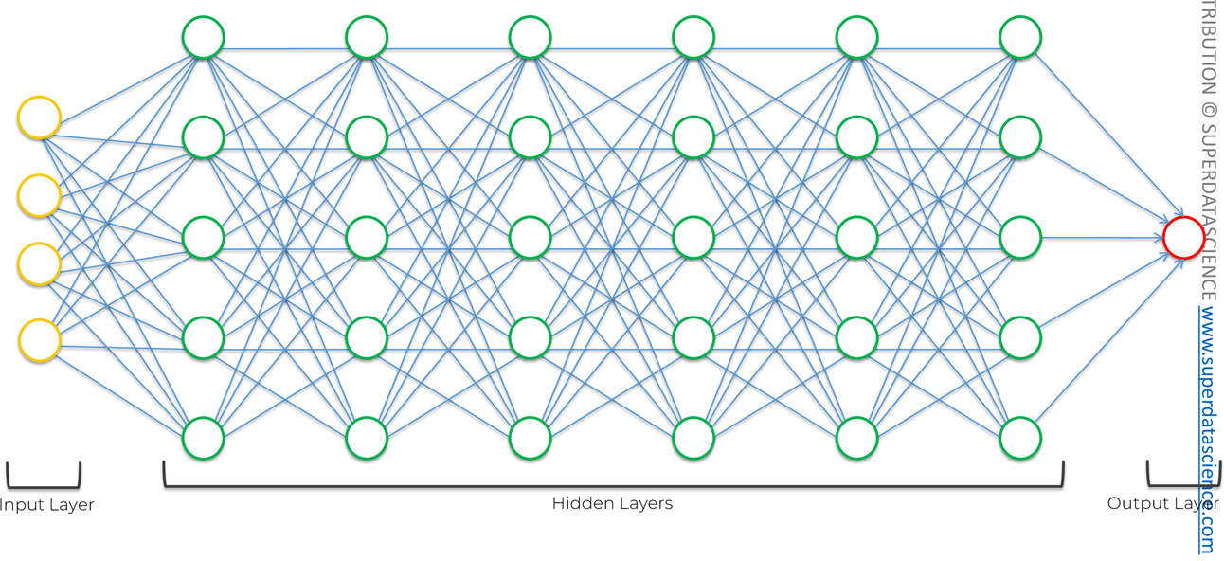

Another process called back-propagationuses algorithms, like gradient descent, to calculate errors in predictions and then adjusts the weights and biases of the function by moving backwards through the layers in an effort to train the model. Together, forward propagation and back propagation allow a neural network to make predictions and correct them for any errors accordingly. Over time, the algorithm becomes gradually more accurate.